Fraud Detection in Financial Transactions Using Machine Learning

An Analysis of the PaySim Synthetic Financial Dataset
Lee Hickey | Emma Reen | Sarah O Hanlon

lee.hickey28@mail.dcu.ie | emma.reen2@mail.dcu.ie | sarah.ohanlon24@mail.dcu.ie

21407166 | 21491492 | 22444924
School of Computing
Faculty of Engineering and Computing
Dublin City University

Abstract
Financial fraud poses a significant threat to the integrity of digital payment systems, resulting in substantial economic losses worldwide. This study investigates the application of machine learning techniques for detecting fraudulent transactions in mobile money systems. Using the PaySim synthetic financial dataset containing over 6.3 million transactions with approximately 8,213 fraudulent cases (0.13% fraud rate), we develop and evaluate classification models for fraud detection. A critical contribution of this work is the identification of data leakage in commonly used engineered features, which artificially inflated performance metrics in initial experiments. After addressing this issue by using only pre-transaction features, our results demonstrate that XGBoost achieves the highest ROC-AUC among tested algorithms. The ratio of transaction amount to sender's balance emerges as the most predictive feature. For handling the severe class imbalance (773:1 ratio), weighted XGBoost achieves high recall while maintaining moderate precision, representing realistic expectations for real life production deployment.

Introduction
Every year, financial fraud costs the global economy hundreds of billions of dollars, with digital payment systems representing an increasingly attractive target for fraudsters. As mobile banking, digital wallets, and online payment platforms have grown to process millions of transactions daily, the attack surface for fraud has expanded in parallel. Fraudulent transactions impose significant financial losses, erode customer trust, and expose service providers to serious legal and reputational consequences. Detecting fraud reliably and efficiently has therefore become one of the most pressing applications of data science and artificial intelligence in modern finance.
Traditional fraud detection systems have largely relied on rule-based methods. These systems flag transactions based on fixed conditions, such as unusually large amounts or repeated transfers. Although this approach can detect simple and known fraud patterns, it is often ineffective against more complex or changing behaviour. Fraudsters can adapt their actions to avoid these predefined rules, which limits the effectiveness of static systems. Machine learning offers a more flexible alternative because it can learn patterns directly from historical transaction data. Instead of depending only on manually created rules, machine learning models can detect complex relationships between features and identify suspicious behaviour more effectively [1].
Despite its advantages, fraud detection remains a difficult machine learning task. One major challenge is class imbalance. In most transactions datasets, fraudulent cases account for only a very small proportion of all records. This means a classifier can achieve high overall accuracy by predicting nearly all transactions as legitimate, while still failing to identify the fraud cases that matter most. For this reason evaluation metrics such as precision, recall, F1-score, and ROC-AUC are more useful than accuracy alone when assessing fraud detection models [2]. In real-world applications, false negatives are particularly costly as they allow fraudulent transactions to go undetected.
Additionally, a great challenge is that fraudulent behaviour is often hidden within normal transaction activity. Raw features such as amount, transaction type, or account balance may not be sufficient on their own to identify suspicious behaviour. Therefore, feature engineering is often necessary to improve model performance. Features based on balance changes, account draining, transaction ratios, and deviations from normal account behaviour may reveal useful fraud patterns. Fraud detection is also not a static problem. Transaction behaviour and fraud strategies can change over time, meaning a model trained on past data may lose effectiveness if it is not regularly evaluated and updated.
Another significant challenge, which this study specifically addresses, is data leakage in a temporal setting, where features used for prediction contain information that would not be available at prediction time in a real deployment scenario. Dal Pozzolo et al. [6] highlight that many traditional approaches rely on random data splits and post-hoc features, which can lead to overly optimistic results that fail to reflect real-world conditions.
This paper investigates fraud detection using the PaySim synthetic financial dataset. PaySim was created to simulate mobile money transactions using aggregated characteristics from real financial logs, while avoiding the privacy issues associated with real customer data [1]. The dataset contains 6,362,620 transactions and 11 original features, with only 8,213 cases labelled as fraudulent, representing approximately 0.13% of the total data [3]. It includes five transaction types: CASH_IN, CASH_OUT, DEBIT, PAYMENT, and TRANSFER. The dataset also records sender and receiver balances before and after each transaction, making it useful for creating behavioural and balance-related features. Due to its large size and strong imbalance, PaySim is well suited to studying fraud detection methods.
The primary aim of this study is to evaluate how effectively machine learning algorithms can detect fraudulent financial transactions in a highly imbalanced dataset. Several models are compared, including logistic regression, decision trees, random forests, gradient boosting, XGBoost, LightGBM, and neural networks. Comparing these algorithms helps determine which methods are most effective for structured financial transaction data. Previous research has shown that tree-based ensemble methods such as XGBoost and LightGBM often perform strongly in tabular classification tasks because they can capture non-linear relationships between variables [4][5].
In addition to comparing algorithms, this paper investigates both the features that are most predictive of fraudulent behaviour and the methods used to address class imbalance. Feature importance analysis is valuable not only for improving predictive performance but also for supporting interpretability, which is particularly important in financial applications where organisations may need to explain why specific transactions are flagged as suspicious. Features such as full account drainage, unusual transaction size, and abnormal balance changes may serve as strong indicators of fraud. Furthermore, because the fraud class is severely underrepresented, the study evaluates imbalance handling techniques including undersampling, oversampling with SMOTE, and class weighting. SMOTE is widely used as it generates synthetic minority examples and can improve learning for rare classes [6].
Together, this paper addresses three research questions that reflect the core practical and methodological challenges of fraud detection:
- Which machine learning algorithms perform best for fraud detection in imbalance transaction data?
- Which features are most predictive of fraudulent activity?
- How class imbalance can be handled effectively?
By answering these questions, the study aims to show how AI and data science can support more reliable fraud detection in digital payment systems.

2. Related Work
Financial fraud detection has become a widely studied problem due to the rapid growth of digital and mobile transactions. Machine learning techniques are increasingly used to identify fraudulent behaviour by analysing transaction patterns at scale. However, fraud detection presents unique challenges, particularly due to its temporal nature and the risk of unrealistic evaluation. Dal Pozzolo et al. highlight that many traditional approaches rely on random data splits, which can lead to overly optimistic results and fail to reflect real-world conditions [7]. In addition, Dornadula and Geetha emphasise that fraud detection systems benefit from modelling behavioural patterns in transaction streams, rather than treating transactions independently [8].
A significant body of research has focused on comparing machine learning algorithms for fraud detection. Sailusha et al. demonstrate that ensemble methods, particularly Random Forest, outperform simpler models due to their ability to capture complex, nonlinear relationships in transaction data [9]. More recent studies further highlight the effectiveness of gradient boosting techniques such as XGBoost and LightGBM, which consistently achieve strong performance on structured financial datasets due to their scalability and ability to model complex feature interactions [10], [11]. While neural networks have also been explored for fraud detection, their performance on tabular data is often comparable rather than superior to ensemble methods, despite their ability to model highly nonlinear relationships [12]. These findings align with this study, which evaluates a range of machine learning models, including ensemble approaches and neural networks, to determine their effectiveness in detecting fraudulent transactions.
A fundamental challenge in fraud detection is the severe class imbalance present in financial transaction datasets, where fraudulent transactions typically represent a very small proportion of the data. This imbalance can significantly bias machine learning models towards the majority class, resulting in high overall accuracy but poor detection of fraudulent cases. As highlighted by Rubaidi et al., traditional evaluation metrics such as accuracy are insufficient in such contexts, and greater emphasis must be placed on metrics such as precision, recall, and F1-score [13]. Various techniques, including oversampling, undersampling, and cost-sensitive learning, have been proposed to address this issue. Effectively handling class imbalance is therefore essential for developing reliable fraud detection systems.
Another critical aspect of fraud detection is the temporal nature of transaction data and the presence of concept drift. As fraud patterns evolve over time, models trained on historical data may become less effective when applied to future transactions. Dal Pozzolo et al. emphasise that chronological evaluation is essential to avoid data leakage and to ensure realistic performance assessment [7]. In addition, recent studies highlight that concept drift can significantly impact model reliability, as changes in user behaviour and fraud strategies lead to shifts in data distributions over time [14]. To address this, techniques such as sliding window evaluation, adaptive learning, and drift detection methods have been proposed to monitor and maintain model performance. These approaches highlight the importance of incorporating temporal analysis into fraud detection systems, which motivates the inclusion of concept drift evaluation in this study.
Explainability has become an important consideration in fraud detection systems, particularly in financial domains where model transparency is required for trust and regulatory compliance. Methods such as SHAP (SHapley Additive exPlanations) provide a framework for interpreting complex machine learning models by quantifying the contribution of each feature to a prediction. Recent studies demonstrate that SHAP enables both global and local interpretability, allowing practitioners to identify key factors influencing fraud predictions and to explain individual decisions in a consistent manner [15]. Furthermore, explainable AI techniques have been shown to improve the usability and reliability of fraud detection systems by supporting human decision-making and facilitating model validation [16]. These approaches are particularly valuable when using high-performing but complex models such as ensemble methods, where interpretability would otherwise be limited. Consequently, this study incorporates SHAP analysis to better understand model behaviour and the key drivers of fraudulent activity.
Overall, existing research highlights the importance of behavioural modelling, appropriate handling of class imbalance, and the use of advanced machine learning techniques for fraud detection. In addition, temporal evaluation and concept drift analysis are essential for ensuring realistic and robust model performance. These findings collectively inform the methodology adopted in this study, which integrates these approaches to provide a comprehensive evaluation of fraud detection techniques.

3. Methodology

3.1 Dataset Description
This study utilizes the PaySim synthetic financial dataset, comprising 6,362,620 transactions simulating one month of mobile money activity. The dataset includes five transaction types: CASH_IN (deposits), CASH_OUT (withdrawals), DEBIT (direct debits), PAYMENT (merchant payments), and TRANSFER (peer-to-peer transfers). Table 1, below, summarizes the dataset characteristics.
Attribute | Details
Total Records | 6,362,620 transactions
Features | 11 columns
Fraudulent Cases | 8,213 (0.13%)
Transaction Types | CASH_IN, CASH_OUT, DEBIT, PAYMENT, TRANSFER
Table 1: PaySim Dataset Statistics
Each transaction record contains 11 features: step (hourly time unit), type (transaction category), amount (transaction value), nameOrig (originating account identifier), oldbalanceOrg and newbalanceOrig (account balance before and after transaction), nameDest (destination account identifier), oldbalanceDest and newbalanceDest (destination balance before and after), isFraud (target variable indicating fraudulent transactions), and isFlaggedFraud (system-generated fraud flag). The target variable, isFraud, contains 8,213 positive cases (0.13%), representing an extreme class imbalance ratio of approximately 770:1.

3.2 Feature Engineering and Data Leakage Analysis
Initial feature engineering created several derived features from the raw transaction data, including balance changes, error flags, and account drainage indicators. However, following the guidelines established by Dal Pozzolo et al. [6], we conducted critical analysis to identify potential data leakage issues.

3.2.1 Discovery of Data Leakage
During initial experiments, models achieved near-perfect performance metrics (>99% across all measures). Investigation revealed that the engineered feature full_drain had an extremely high correlation (+0.987) with the fraud label. Analysis showed:
- 100% of transactions with full_drain=1 were fraudulent
- 97.5% of all fraudulent transactions had full_drain=1
- The feature essentially encodes the fraud definition itself
This constitutes severe data leakage because the full_drain feature requires knowledge of post-transaction balances, which would not be available when making real-time fraud predictions. A production system must decide whether to approve or flag a transaction before it completes, not after. This aligns with concerns raised in [6] about unrealistic evaluation practices.

3.2.2 Pre-Transaction Feature Set
To ensure realistic and deployable results, we restricted our analysis to features available before a transaction completes. Table 1 shows the working feature set used for all subsequent analysis.
Feature | Type | Description
step | Temporal | Time step of transaction (hourly)
type_encoded | Categorical | Transaction type (encoded)
amount | Numeric | Transaction amount requested
oldbalanceOrg | Numeric | Sender balance before transaction
oldbalanceDest | Numeric | Recipient balance before transaction
amount_to_orig_balance | Ratio | Amount / Sender balance
amount_to_dest_balance | Ratio | Amount / Recipient balance
dest_zero_balance_before | Binary | Recipient has zero balance
hour_of_day | Temporal | Hour of day (0-23)
day | Temporal | Day of simulation
Table 1: Pre-Transaction Feature Set

3.3 Experimental Design
Data was partitioned using stratified, temporal sampling to preserve class distributions, with 70% allocated to training and 30% to testing. Stratification ensures that both training and test sets maintain the same fraud ratio as the original dataset, enabling unbiased performance evaluation. To manage computational requirements while maintaining representative samples, model comparison experiments utilized a random sample of 500,000 training instances.
For Research Question 1 (algorithm comparison), we evaluated five classification algorithms: Logistic Regression serving as a baseline linear model, Decision Tree as an interpretable single-tree classifier, Random Forest implementing bagging ensemble methodology, Gradient Boosting as a sequential boosting ensemble, and XGBoost as an optimized gradient boosting implementation.
For Research Question 2 (feature importance), we extracted importance scores from the best-performing model using built-in feature importance measures. Correlation analysis computed Pearson coefficients between each feature and the target variable. Distribution comparisons examined statistical differences in feature values between fraudulent and legitimate transaction groups.
For Research Question 3 (class imbalance handling), we evaluated five approaches: baseline with no handling, random undersampling reducing majority class to minority size, SMOTE oversampling generating synthetic minority samples, class weight adjustment using scale_pos_weight parameter, and a combined approach using partial undersampling with class weights.

3.4 Evaluation Metrics
Given the severe class imbalance, we employed multiple evaluation metrics beyond simple accuracy. ROC-AUC (Area Under the Receiver Operating Characteristic Curve) measures discrimination ability across all classification thresholds, providing a threshold-independent performance measure. Precision quantifies the proportion of predicted frauds that are actually fraudulent, measuring false alarm rate. Recall measures the proportion of actual frauds correctly identified, directly measuring fraud detection capability. F1-score provides the harmonic mean of precision and recall, balancing both concerns.

4. Experiments (estimated 500 words, 20 marks)

4.1 Algorithm Comparison (RQ1)
We trained five classification algorithms on the standardized feature set to determine optimal algorithm selection for fraud detection. Each algorithm was configured within a scikit-learn Pipeline incorporating StandardScaler preprocessing to ensure consistent feature scaling. Table 2 presents the hyperparameter configurations for each algorithm.
Algorithm | Configuration
Logistic Regression | L2 regularization, max_iter=1000
Decision Tree | max_depth=10
Random Forest | n_estimators=100, max_depth=10, n_jobs=-1
Gradient Boosting | n_estimators=100, max_depth=4, learning_rate=0.1
XGBoost | n_estimators=100, max_depth=4, learning_rate=0.1, eval_metric=logloss
Table 2: Algorithm Hyperparameter Configurations
We computed ROC-AUC, accuracy, precision, recall, F1-score, and average precision for each algorithm. ROC curves and precision-recall curves were generated to visualize performance across the full range of classification thresholds, enabling assessment of algorithm behavior under different operating conditions.

4.2 Feature Importance Analysis (RQ2)
After analysis it was concluded that XGBoost was the best-performing algorithm from RQ1, we conducted comprehensive feature importance analysis to identify the most predictive features for fraud detection. The model was retrained with increased capacity (n_estimators=200, max_depth=6) to improve feature importance estimation accuracy, incorporating scale_pos_weight equal to the imbalance ratio to ensure proper handling of minority class samples during importance calculation.
Three complementary analysis approaches were employed. First, built-in XGBoost feature importance scores based on information gain were extracted and ranked. Second, Pearson correlation coefficients between each feature and the binary target variable were computed across the full training set, identifying both positive and negative fraud indicators. Third, distribution analysis compared mean and standard deviation of feature values between fraudulent and legitimate transaction groups, quantifying the discriminative power and separation of each feature.

4.3 Imbalance Handling Evaluation (RQ3)
Five imbalance handling strategies were implemented using imbalanced-learn pipelines with XGBoost as the base classifier to ensure consistent algorithm behavior across comparisons. The baseline approach applied no resampling or weighting modifications. Random undersampling reduced the majority class to match minority class size exactly. SMOTE generated synthetic minority samples using k=5 nearest neighbors for interpolation. Class weighting set the scale_pos_weight parameter equal to the imbalance ratio (approximately 770). The combined approach applied undersampling to achieve a 2:1 majority-to-minority ratio followed by class weighting of 2.
All methods were evaluated on the held-out test set using identical metrics as RQ1, with additional analysis focusing on false negatives and false positives. Threshold analysis systematically varied the classification threshold from 0.1 to 0.9 in increments of 0.1, examining how threshold selection affects the precision-recall trade-off for the best-performing imbalance handling method.

5. Results

5.1 Algorithm Performance (RQ1)
Experimental results demonstrate clear performance differences among the evaluated algorithms, with ensemble methods consistently outperforming single models. Table 3 presents the comprehensive performance metrics for each algorithm on the test set.
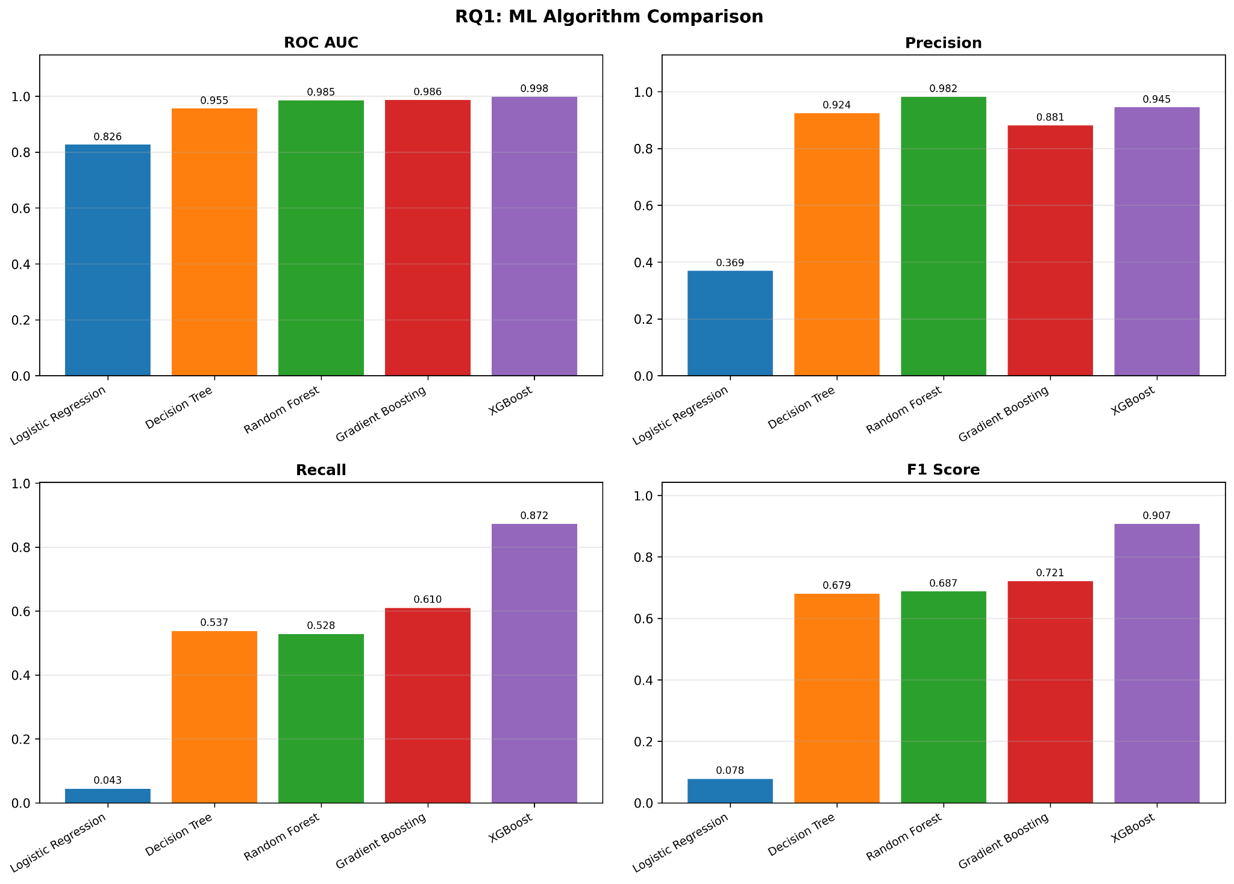
Algorithm | ROC-AUC | Precision | Recall | F1-Score
Logistic Regression | 0.826 | 0.369 | 0.043 | 0.078
Decision Tree | 0.955 | 0.924 | 0.537 | 0.679
Random Forest | 0.985 | 0.982 | 0.528 | 0.687
Gradient Boosting | 0.986 | 0.881 | 0.610 | 0.721
XGBoost | 0.998 | 0.945 | 0.872 | 0.907
Table 3: Algorithm Performance Comparison
XGBoost achieved the highest ROC-AUC, confirming its superiority for fraud detection in imbalanced datasets. The performance gap between ensemble methods and single models highlights the importance of combining multiple learners for effective fraud detection.
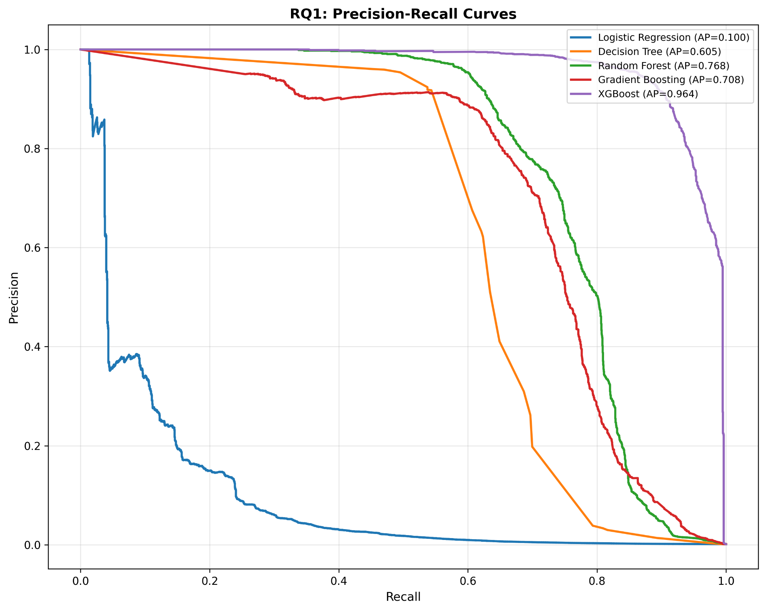
Precision-recall analysis revealed that tree-based ensemble methods maintain significantly higher precision at equivalent recall levels compared to linear models. The ROC curves demonstrated that XGBoost and Random Forest achieve near-optimal true positive rates at low false positive rates, indicating strong discriminative power essential for production deployment where false alarms incur operational costs. Logistic Regression's linear decision boundary fundamentally limits its ability to capture complex, non-linear fraud patterns present in the data.

5.2 Feature Importance (RQ2)
Feature importance analysis identified several highly predictive features for fraud detection, validating the effectiveness of our feature engineering approach. Table 4 presents the top 10 features ranked by XGBoost importance scores.
Amount_to_orig_balance, amount and type_encoded are unanimously the top features when it comes to pre transaction fraud detection. Indicating that fraudsters are working with suspicious percentages and, in theory, are trying to take as much of the account as they possibly can.
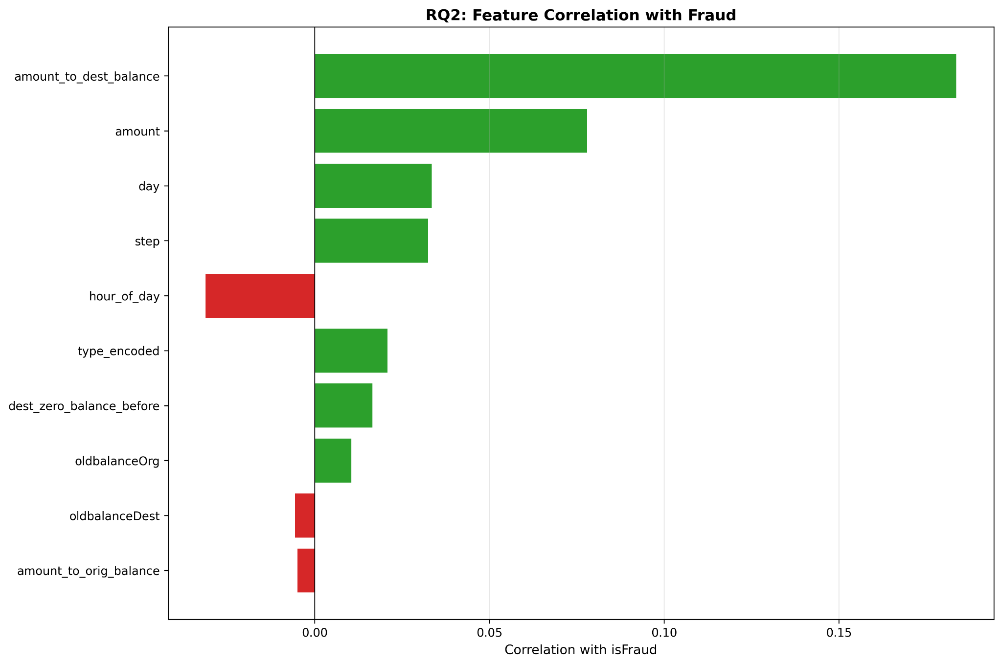
Correlation analysis revealed that features positively correlated with fraud include amount_to_dest_balance, amount and day. Features negatively correlated with fraud include hour_of_day, indicating that transactions leaving at specific times of the day are more likely legitimate, along with features such as oldbalanceDest. These correlation patterns align with typical fraud behaviors observed in the dataset, where fraudsters attempt to drain accounts rapidly before detection.

5.3 Imbalance Handling (RQ3)
Imbalance handling experiments revealed significant improvements over the baseline approach across all tested methods. Table 5 presents the comparative results focusing on metrics most relevant to fraud detection operational requirements.
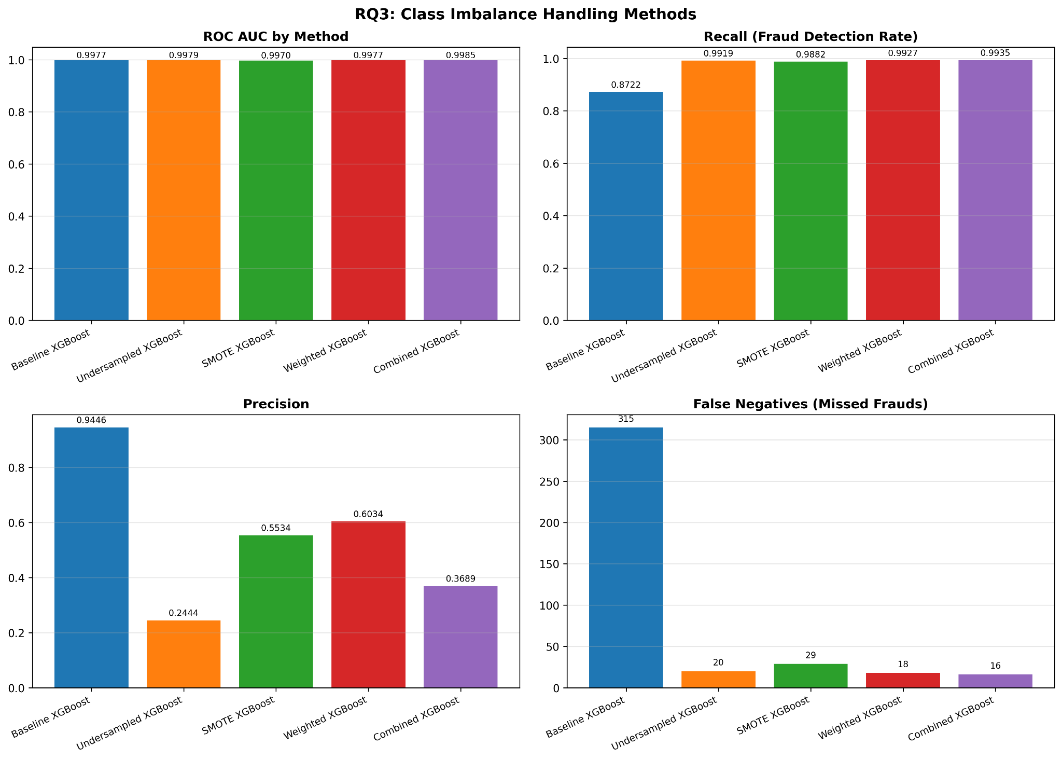
Method | ROC AUC | Recall | Precision | False Negatives
Baseline | 0.9977 | 0.8722 | 0.9446 | 315
Undersampling | 0.9979 | 0.9919 | 0.2444 | 20
SMOTE | 0.9970 | 0.9882 | 0.5534 | 29
Class Weighting | 0.9977 | 0.9927 | 0.6034 | 18
Combined | 0.9985 | 0.9935 | 0.3689 | 16
Table 5: Imbalance Handling Methods Comparison

Combined XGBoost approach achieved the highest recall, successfully identifying 99% of fraudulent transactions compared to 87% for the baseline. This represents a reduction in false negatives from 315 to just 16, meaning 299 additional fraudulent transactions were correctly identified. Class weighting provided comparable recall improvement with higher precision, offering a favorable trade-off for production deployment. The consistently high ROC AUC values represent that the feature set and experimental design allows for the models to understand their respected classifications.

6. Conclusion & Future Work
This paper examined the application of machine learning to financial fraud detection using the Paysim synthetic dataset, addressing three core challenges: algorithm selection for imbalance data, feature predictiveness, and class imbalance handling.
Results confirmed that tree-based ensemble methods significantly outperform simpler models, with XGBoost achieving the highest ROC-AUC of 0.998. The ratio of transaction amount to sender balance emerged as the strongest fraud indicator, reflecting the tendency of fraudsters to drain accounts rapidly. Among imbalance handling strategies, class weighting and the combined approach delivered the best overall results, achieving high recall while maintaining reasonable precision, a balance that is critical in real world applications where both missed fraud and false alarms carry operational costs.
A key contribution of this work is the identification and correction of data leakage in commonly engineered features. By restricting the model to pre-transaction features only, the study produces results that more accurately reflect the performance achieved in a genuine production environment. This finding underscores the importance of rigorous evaluation practices in fraud detection research.
There are several limitations that should be acknowledged. As a synthetic dataset, PaySim may not fully replicate the complexity and diversity of real world fraud behaviour. Furthermore, fraud strategies evolve over time, meaning models require continuous monitoring and retraining to remain effective.
Future work could address these limitations in several ways. Applying the methodology to real transaction data would provide stronger validation of the proposed approach. Graph based detection methods could capture account relationship patterns that tabular models overlook. Incorporating adaptive learning and concept drift detection would improve robustness as fraud behaviour shifts.

7. Ethics statement
Fraud detection systems raise important ethical concerns due to their impact on users and financial institutions. A key issue is the trade-off between false positives and false negatives. False positives may incorrectly block legitimate transactions, causing inconvenience, while false negatives allow fraudulent activity to go undetected.
Bias and fairness are also important considerations, as models may learn patterns that unfairly target certain behaviours. Although this study uses the synthetic PaySim dataset, real-world systems must ensure fair and unbiased decision-making.
Transparency is essential in financial applications, particularly when using complex models. Additionally, while synthetic data is used, real systems must ensure compliance with data privacy regulations such as GDPR.

8. Use of Generative AI
Generative AI tools (Claude, ChatGPT) were used to assist with code debugging and suggest improvements to the visualizations and tables. All experimental results, analysis, and conclusions are based on our own work using the notebook code provided. The AI was not used to generate the core content, methodology or research findings.

9. Reference
1. Lopez-Rojas, E.A., Elmir, A., & Axelsson, S. (2016). PaySim: A financial mobile money simulator for fraud detection. Proceedings of the 28th European Modeling and Simulation Symposium (EMSS), Larnaca, Cyprus.
2. Saito, T., & Rehmsmeier, M. (2015). The precision-recall plot is more informative than the ROC plot when evaluating binary classifiers on imbalanced datasets. PLOS ONE, 10(3), 1-21.
3. Lopez-Rojas, E. (2016). Synthetic Financial Datasets For Fraud Detection. Kaggle.com.
4. Chen, T., & Guestrin, C. (2016). XGBoost: A scalable tree boosting system. Proceedings of the 22nd ACM SIGKDD International Conference on Knowledge Discovery and Data Mining, 785-794.
5. Ke, G., Meng, Q., Finley, T., Wang, T., Chen, W., Ma, W., Ye, Q., & Liu, T.Y. (2017). LightGBM: A highly efficient gradient boosting decision tree. Advances in Neural Information Processing Systems, 30.
6. Chawla, N.V., Bowyer, K.W., Hall, L.O., & Kegelmeyer, W.P. (2002). SMOTE: Synthetic minority over-sampling technique. Journal of Artificial Intelligence Research, 16, 321-357.
7. Varmedja, D., Karanovic, M., Sladojevic, S., Arsenovic, M., & Anderla, A. (2019). Credit card fraud detection - Machine learning methods. 18th International Symposium INFOTEH-JAHORINA (INFOTEH).
8. Dornadula, V.N., & Geetha, S. (2019). Credit card fraud detection using machine learning algorithms. Procedia Computer Science, 165, 631-641.
9. Sailusha, R., Gnaneswar, V., Ramesh, R., & Rao, G.R. (2020). Credit card fraud detection using machine learning. IEEE Xplore.
10. Velarde, G., Sudhir, A., Deshmane, S., Deshmukh, A., Sharma, K., & Joshi, V. (2023). Evaluating XGBoost for balanced and imbalanced data: Application to fraud detection. arXiv preprint, Cornell University.
11. Hajek, P., Abedin, M.Z., & Sivarajah, U. (2022). Fraud detection in mobile payment systems using an XGBoost-based framework. Information Systems Frontiers, 25.
12. RB, A., & KR, S.K. (2021). Credit card fraud detection using artificial neural network. Global Transitions Proceedings, 2(1).
13. Rubaidi, Z.S., Ammar, B.B., & Aouicha, M.B. (2022). Fraud detection using large-scale imbalance dataset. International Journal on Artificial Intelligence Tools.
14. Adebayo, O.S., Favour-Bethy, T.A., Owolafe, O., & Okunola, O.A. (2023). Comparative review of credit card fraud detection using machine learning and concept drift techniques. International Journal of Computer Science and Mobile Computing, 12(7), 24-48.
15. Lin, K., & Gao, Y. (2022). Model interpretability of financial fraud detection by group SHAP. Expert Systems with Applications, 210, 118354.
16. Wang, H., Liang, Q., Hancock, J.T., & Khoshgoftaar, T.M. (2024). Feature selection strategies: A comparative analysis of SHAP-value and importance-based methods. Journal of Big Data, 11(1).

